WEEK_5 – Angular
Exercise 1: Environment Setup, Project Structure & First
Component

Task 1: Scaffold and Explore the Angular Project
Scenario
You are required to set up an Angular development environment and build the initial version of the Student Course Portal application. The application should be created using Angular CLI, the project structure should be explored, and the first set of components should be generated and displayed successfully.
Steps
- Install Angular CLI using npm.
- Create a new Angular project named student-course-portal with routing enabled and CSS as the stylesheet format.
- Open the project in Visual Studio Code.
- Create a notes.txt file and document the purpose of the important Angular project files.
- Run the application using the ng serve command and verify it loads successfully in the browser.
- Build the project using the ng build command and verify the dist folder is created.
- Observe the budgets configuration in angular.json.
Solution Code
Commands Used
npm install -g @angular/cli
ng new student-course-portal --routing --style=css
cd student-course-portal
ng serve
ng build

OUTPUT:
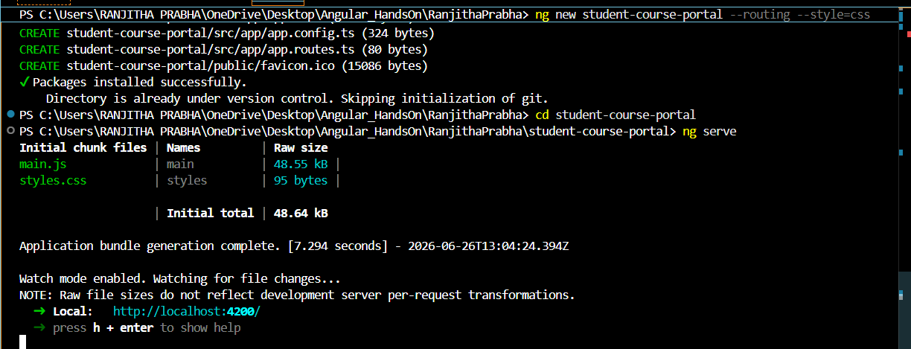

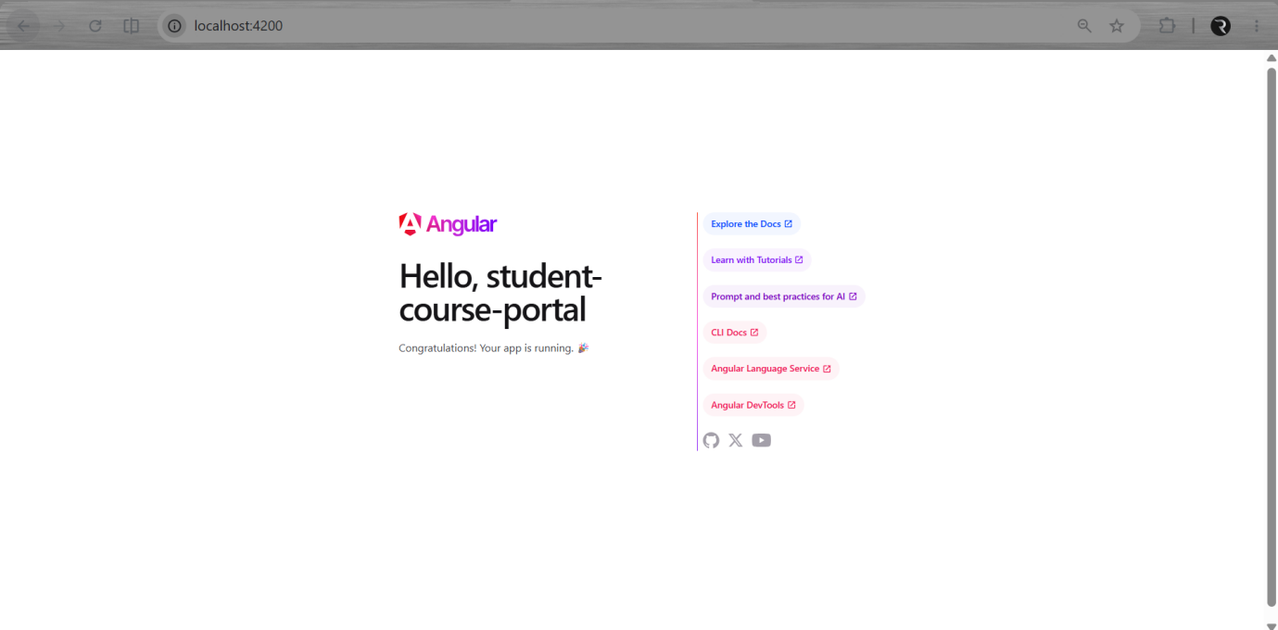
Task 2: Create and Organise Components
Scenario
You are required to organize the Student Course Portal application by creating reusable Angular components. The application should include separate components for the Header, Home, Course List, and Student Profile. These components should be integrated into the application to improve code organization and maintainability.

Steps
- Generate the Header component.
- Generate the Home component.
- Generate the Course List component.
- Generate the Student Profile component.
- Modify the header.component.html file to display the portal title and navigation links.
- Modify the home.component.html file to display a welcome message and student statistics.
- Update the app.component.html file to include the Header component and Router Outlet.
- Run the application using the ng serve command.
- Verify that the Header and Home page are displayed successfully in the browser.
Solution Code
header.component.ts
import { Component } from '@angular/core';
@Component({
selector: 'app-header',
standalone: true,
templateUrl: './header.component.html',
styleUrls: ['./header.component.css']
})
export class HeaderComponent { }
header.component.html
<nav style="padding:10px; background-color:#1976d2; color:white;">
<h2>Student Course Portal</h2>

<a href="#" style="margin-right:15px; color:white;">Home</a>
<a href="#" style="margin-right:15px; color:white;">Courses</a>
<a href="#" style="color:white;">Profile</a>
</nav>
home.component.ts
import { Component } from '@angular/core';
@Component({
selector: 'app-home',
standalone: true,
templateUrl: './home.component.html',
styleUrls: ['./home.component.css']
})
export class HomeComponent { }
home.component.html
<h1>Welcome to Student Course Portal</h1>
<p>
This portal helps students manage courses, track progress, and view academic performance.
</p>
<div style="display:flex; gap:20px; margin-top:20px;">
<div>Courses Available: <b>12</b></div>
<div> Enrolled: <b>3</b></div>
<div> GPA: <b>3.8</b></div>
</div>

app.component.ts
import { Component } from '@angular/core';
import { RouterOutlet } from '@angular/router';
import { HeaderComponent } from './components/header/header.component';
@Component({
selector: 'app-root',
standalone: true,
imports: [RouterOutlet, HeaderComponent],
templateUrl: './app.component.html',
styleUrls: ['./app.component.css']
})
export class AppComponent { }
app.component.html
<app-header></app-header>

<div style="padding:20px;">
<router-outlet></router-outlet>
</div>
app.routes.ts
import { Routes } from '@angular/router';
import { HomeComponent } from './pages/home/home.component';

export const routes: Routes = [
{ path: '', component: HomeComponent }
];
main.ts
import { bootstrapApplication } from '@angular/platform-browser';
import { AppComponent } from './app/app.component';
import { provideRouter } from '@angular/router';
import { routes } from './app/app.routes';

bootstrapApplication(AppComponent, {
providers: [provideRouter(routes)]
});
OUTPUT:
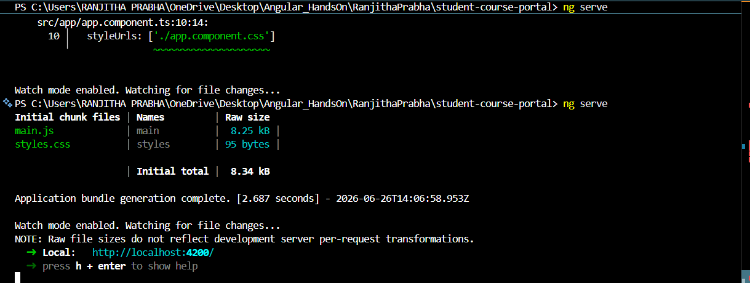
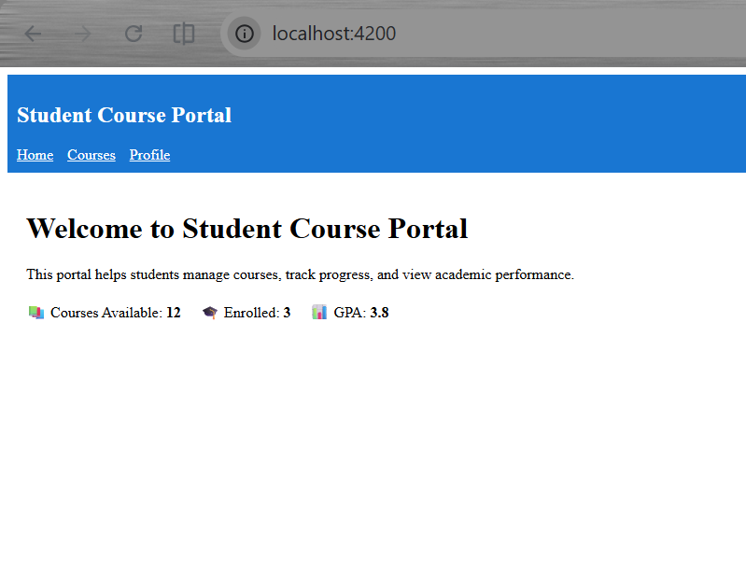

Exercise 2 : Data Binding, Lifecycle Hooks & Component Communication
Task 1: All Four Binding Types
Scenario:
You are developing the Home page of the Student Course Portal using Angular.
The page should display dynamic data and allow user interaction using all four Angular binding types.
This helps you understand how data flows between the component and the UI.
Steps:
1. Create properties in HomeComponent:
- portalName
- isPortalActive
- searchTerm
- message
2. Display portalName in HTML using interpolation ({{ }}).
3. Add a button and control its state using property binding ([disabled]) based on isPortalActive.
4. Create a method onEnrollClick() and trigger it using event binding ((click)) to show a message.
5. Add an input box and bind it with searchTerm using two-way binding ([(ngModel)]).
6. Display live input value below the textbox.
7. Import FormsModule in the component to enable ngModel.
8. Run the application using ng serve and verify all bindings work correctly.
Solution Code:
home.component.ts
import { Component } from '@angular/core';
import { FormsModule } from '@angular/forms';

@Component({
selector: 'app-home',
standalone: true,
imports: [FormsModule],
templateUrl: './home.component.html',
styleUrls: ['./home.component.css']
})
export class HomeComponent {

// Interpolation
portalName: string = 'Student Course Portal';

// Property binding
isPortalActive: boolean = true;

// Event binding message
message: string = '';

// Two-way binding
searchTerm: string = '';

// Event handler
onEnrollClick() {
this.message = 'Enrollment opened!';
}
}
home.component.html
<h1>{{ portalName }}</h1>
<hr>
<button [disabled]="!isPortalActive" (click)="onEnrollClick()">
Enroll Now
</button>
<p>{{ message }}</p>
<hr>
<input type="text" [(ngModel)]="searchTerm" placeholder="Search courses">
<p>Searching for: {{ searchTerm }}</p>
home.component.css
button {
padding: 8px 12px;
background-color: #1976d2;
color: white;
border: none;
cursor: pointer;
}

input {
padding: 6px;
margin-top: 10px;
}

Output:
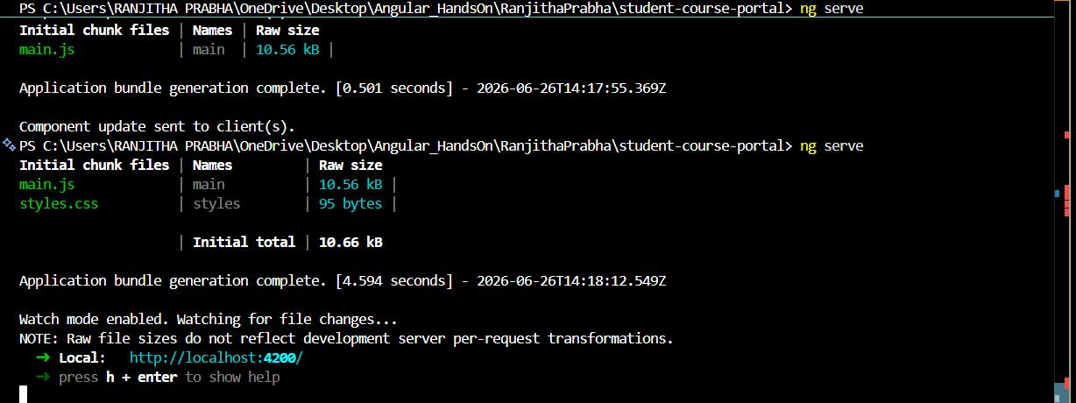
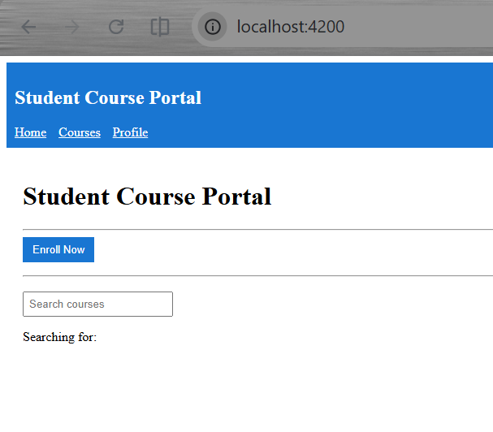
Task 2: Lifecycle Hooks
Scenario:
You are enhancing the Student Course Portal by tracking component behavior using Angular lifecycle hooks.
This helps observe when components are created, updated, and destroyed during navigation.
It also demonstrates how data changes flow into child components using @Input() and ngOnChanges.
Steps:
1. Implement ngOnInit() in HomeComponent to simulate loading course data and log initialization message.
2. Implement ngOnDestroy() in HomeComponent to log when the component is destroyed during navigation.
3. Create CourseCardComponent with an @Input() property to receive course data.
4. Implement ngOnChanges() in CourseCardComponent to log previous and current input values.
5. Render multiple CourseCardComponents in CourseListComponent and verify console logs for all lifecycle hooks.
Solution:
home.component.ts
import { Component, OnInit, OnDestroy } from '@angular/core';

@Component({
selector: 'app-home',
standalone: true,
templateUrl: './home.component.html',
styleUrls: ['./home.component.css']
})
export class HomeComponent implements OnInit, OnDestroy {

courseCount: number = 0;

ngOnInit(): void {
// Simulate API call
this.courseCount = 12;

console.log('HomeComponent initialised — courses loaded');
}

ngOnDestroy(): void {
console.log('HomeComponent destroyed');
}
}
home.component.html
<h1>Welcome to Student Course Portal</h1>
<p>Available Courses: {{ courseCount }}</p>
course-card.component.ts
import { Component, Input, OnChanges, SimpleChanges } from '@angular/core';

@Component({
selector: 'app-course-card',
standalone: true,
templateUrl: './course-card.component.html',
styleUrls: ['./course-card.component.css']
})
export class CourseCardComponent implements OnChanges {

@Input() course: any;

ngOnChanges(changes: SimpleChanges): void {

if (changes['course']) {
console.log('Previous Value:', changes['course'].previousValue);
console.log('Current Value:', changes['course'].currentValue);
}
}
}
course-card.component.html
<div style="border:1px solid gray; padding:10px; margin:10px;">
<h3>{{ course?.name }}</h3>
<p>Duration: {{ course?.duration }}</p>
</div>
course-list.component.ts
import { Component } from '@angular/core';
import { CourseCardComponent } from '../../components/course-card/course-card.component';

@Component({
selector: 'app-course-list',
standalone: true,
imports: [CourseCardComponent],
templateUrl: './course-list.component.html',
styleUrls: ['./course-list.component.css']
})
export class CourseListComponent {

courses = [
{ name: 'Angular Basics', duration: '5 Days' },
{ name: 'TypeScript Essentials', duration: '3 Days' },
{ name: 'RxJS Fundamentals', duration: '4 Days' }
];
}
course-list.component.html
<h2>Course List</h2>

<app-course-card
*ngFor="let c of courses"
[course]="c">
</app-course-card>
Output:
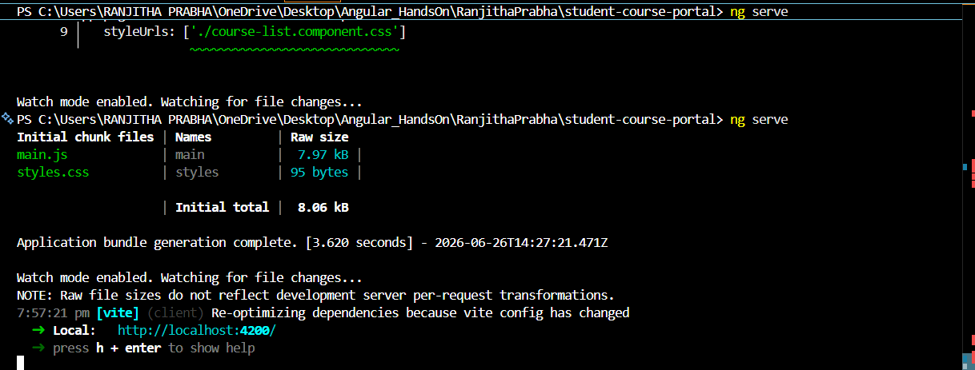
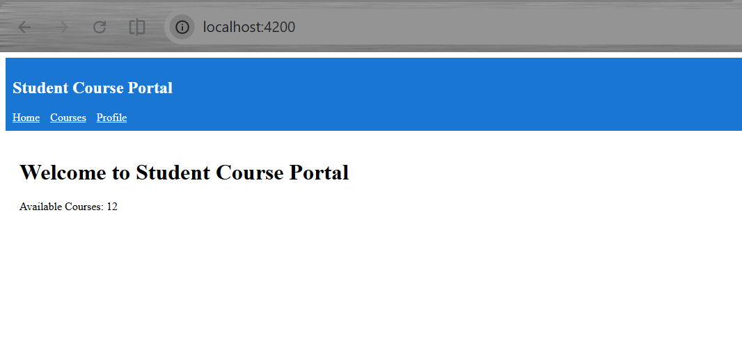

Task 3: @Input and @Output — Parent-Child Communication
Scenario:
The application displays a list of courses using reusable course cards.
When a user clicks Enroll, the selected course ID is sent from child to parent and displayed.
Steps:
1. Create CourseCardComponent and define @Input() to receive course data.
2. Display course details (id, name, code, credits) in the child template.
3. Add @Output() with EventEmitter<number> to send selected course ID.
4. In CourseListComponent, create a courses array and display cards using *ngFor.
5. Handle the event using onEnroll() and show selected course ID.
Solution Code:
course-card.component.ts
import { Component, Input, Output, EventEmitter } from '@angular/core';

@Component({
selector: 'app-course-card',
templateUrl: './course-card.component.html'
})
export class CourseCardComponent {

@Input() course!: { id: number, name: string, code: string, credits: number };

@Output() enrollRequested = new EventEmitter<number>();

enroll() {
this.enrollRequested.emit(this.course.id);
}
}
course-card.component.html
<div class="card">
<p>Id: {{ course.id }}</p>
<p>Name: {{ course.name }}</p>
<p>Code: {{ course.code }}</p>
<p>Credits: {{ course.credits }}</p>

<button (click)="enrollRequested.emit(course.id)">
Enroll
</button>
</div>
course-list.component.ts
import { Component } from '@angular/core';

@Component({
selector: 'app-course-list',
templateUrl: './course-list.component.html'
})
export class CourseListComponent {

selectedCourseId!: number | null;

courses = [
{ id: 1, name: 'Angular Basics', code: 'ANG101', credits: 3 },
{ id: 2, name: 'Java Programming', code: 'JAV102', credits: 4 },
{ id: 3, name: 'Data Structures', code: 'DS103', credits: 3 },
{ id: 4, name: 'Database Systems', code: 'DB104', credits: 3 },
{ id: 5, name: 'Cloud Computing', code: 'CC105', credits: 4 }
];

onEnroll(courseId: number) {
console.log('Enrolling in course: ' + courseId);
this.selectedCourseId = courseId;
}
}
course-list.component.html
<div>
<app-course-card
*ngFor="let c of courses"
[course]="c"
(enrollRequested)="onEnroll($event)">
</app-course-card>

<p *ngIf="selectedCourseId">
Selected course ID: {{ selectedCourseId }}
</p>
</div>
Output:
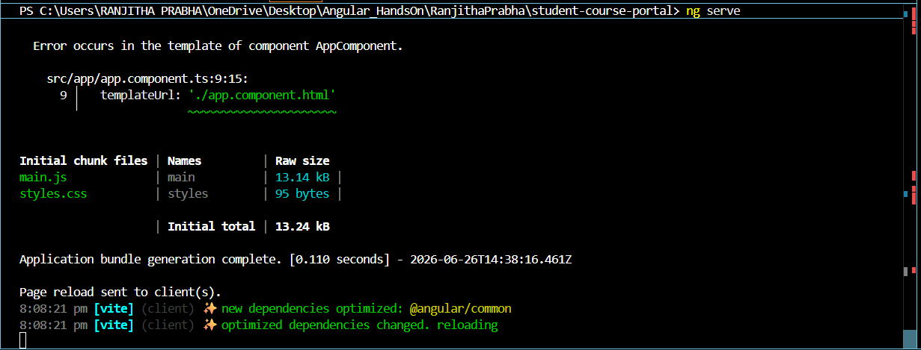

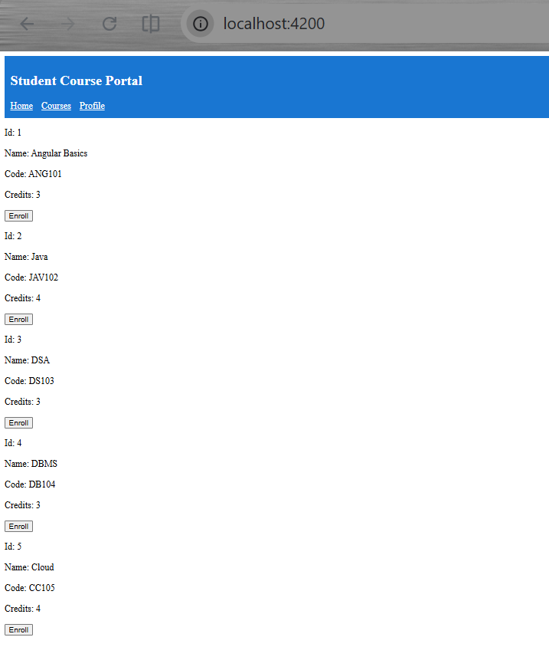

Exercise 3 : Directives & Pipes — Built-in and Custom
Task 1: Structural Directives
Scenario:
The application dynamically controls the course list UI using Angular structural directives.
It shows loading state, renders courses efficiently, and displays status-based badges.
Steps:
1. Add isLoading = true and show loading text using *ngIf.
2. Use setTimeout in ngOnInit() to simulate API loading and set isLoading = false.
3. Render courses using *ngFor with trackByCourseId for performance optimization.
4. Add gradeStatus and display badges using *ngSwitch in child component.
5. Use *ngIf ... else to show “No courses available” when array is empty.
Solution Code:
course-list.component.ts
import { Component, OnInit } from '@angular/core';
import { CommonModule } from '@angular/common';
import { CourseCardComponent } from '../../components/course-card/course-card.component';

@Component({
selector: 'app-course-list',
standalone: true,
imports: [CommonModule, CourseCardComponent],
templateUrl: './course-list.component.html'
})
export class CourseListComponent implements OnInit {

isLoading = true;

courses = [
{ id: 1, name: 'Angular', code: 'ANG101', credits: 3, gradeStatus: 'passed' },
{ id: 2, name: 'Java', code: 'JAV102', credits: 4, gradeStatus: 'failed' },
{ id: 3, name: 'DSA', code: 'DS103', credits: 3, gradeStatus: 'pending' }
];

ngOnInit() {
// Simulating API delay
setTimeout(() => {
this.isLoading = false;
}, 1500);
}

trackByCourseId(index: number, course: any) {
// Improves performance by preventing unnecessary re-rendering
// Angular reuses DOM elements when IDs are same instead of recreating them
return course.id;
}
}
course-list.component.html
<p *ngIf="isLoading">Loading courses...</p>

<div *ngIf="!isLoading; else noCourses">

<app-course-card
*ngFor="let course of courses; let i = index; trackBy: trackByCourseId"
[course]="course">
</app-course-card>

</div>

<ng-template #noCourses>
<p>No courses available.</p>
</ng-template>
course-card.component.ts
import { Component, Input } from '@angular/core';

@Component({
selector: 'app-course-card',
standalone: true,
templateUrl: './course-card.component.html'
})
export class CourseCardComponent {

@Input() course!: {
id: number,
name: string,
code: string,
credits: number,
gradeStatus: string
};
}
course-card.component.html
<div class="card">
<p>Id: {{ course.id }}</p>
<p>Name: {{ course.name }}</p>
<p>Code: {{ course.code }}</p>
<p>Credits: {{ course.credits }}</p>

<!-- Switch for grade status -->
<div [ngSwitch]="course.gradeStatus">

<span *ngSwitchCase="'passed'" style="color: green;">Passed</span>
<span *ngSwitchCase="'failed'" style="color: red;">Failed</span>
<span *ngSwitchCase="'pending'" style="color: gray;">Pending</span>

</div>
</div>
Output:
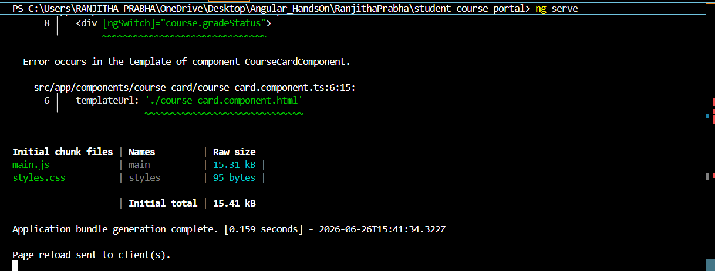
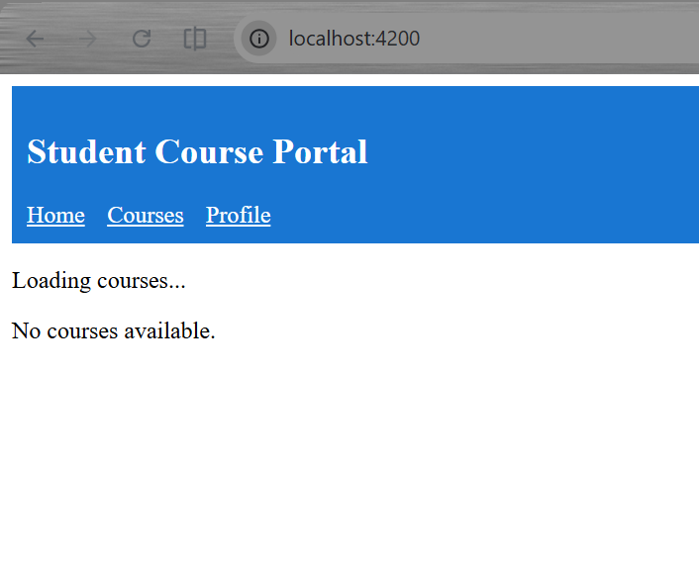

Task 2: Attribute Directives — ngClass and ngStyle
Scenario:
The application dynamically styles each course card using Angular attribute directives.
It changes appearance based on enrollment, credits, and grade status.
Steps:
1. Use ngClass to apply card--enrolled and card--full conditionally.
2. Use ngStyle to change border color based on gradeStatus.
3. Add isExpanded to toggle expanded view on button click.
4. Refactor class logic into a getter cardClasses.
5. Bind everything cleanly using [ngClass] and [ngStyle].
Solution Code:
course-card.component.ts
import { Component, Input } from '@angular/core';
import { CommonModule } from '@angular/common';

@Component({
selector: 'app-course-card',
standalone: true,
imports: [CommonModule],
templateUrl: './course-card.component.html',
styleUrls: ['./course-card.component.css']
})
export class CourseCardComponent {

@Input() course!: {
id: number,
name: string,
code: string,
credits: number,
gradeStatus: string,
enrolled?: boolean
};

isExpanded = false;

toggleExpand() {
this.isExpanded = !this.isExpanded;
}

// Getter keeps template clean and readable
get cardClasses() {
return {
'card--enrolled': this.course?.enrolled,
'card--full': this.course?.credits >= 4,
'expanded': this.isExpanded
};
}

getBorderStyle() {
return {
'border-left': '6px solid ' + this.getColor()
};
}

private getColor(): string {
switch (this.course.gradeStatus) {
case 'passed': return 'green';
case 'failed': return 'red';
default: return 'gray';
}
}
}
course-card.component.html
<div class="card"
[ngClass]="cardClasses"
[ngStyle]="getBorderStyle()">

<p>Id: {{ course.id }}</p>
<p>Name: {{ course.name }}</p>
<p>Code: {{ course.code }}</p>
<p>Credits: {{ course.credits }}</p>

<p>Status: {{ course.gradeStatus }}</p>

<button (click)="toggleExpand()">
Show Details
</button>

<div *ngIf="isExpanded">
<p>Additional course details shown here...</p>
</div>

</div>
course-card.component.css
.card {
padding: 12px;
margin: 10px;
border: 1px solid #ccc;
transition: all 0.3s ease;
}
.card--enrolled {
background-color: #e6f7ff;
}
.card--full {
opacity: 0.6;
}
.expanded {
height: 200px;
transform: scale(1.02);
}
Output:
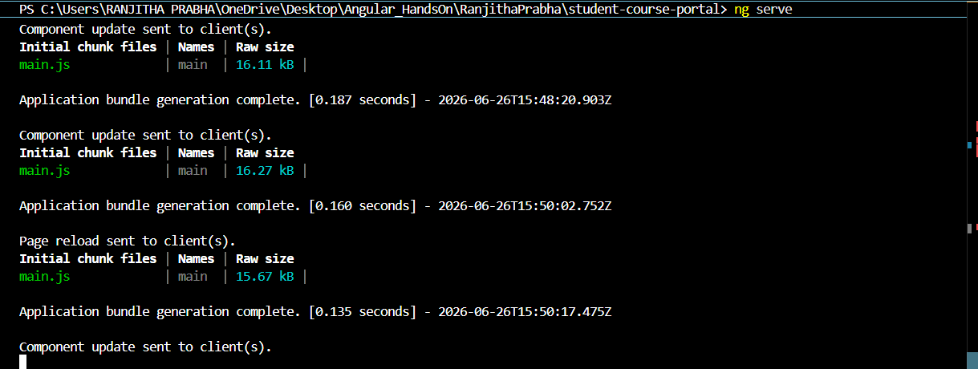

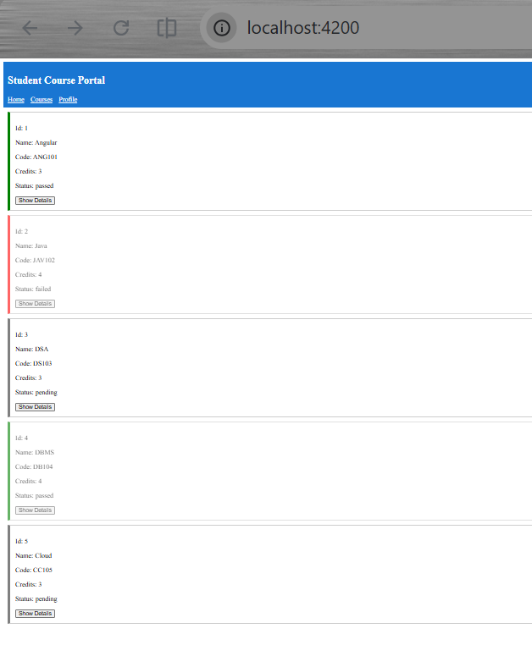
Task 3: Custom Directive and Custom Pipe
Scenario:
The application enhances user experience using a custom directive and pipe.
Cards highlight on hover and credits are displayed in a readable format.
Steps:
1. Create a custom directive appHighlight using @HostListener.
2. Apply hover effect (mouseenter → color, mouseleave → reset).
3. Make directive configurable using @Input() for custom color.
4. Create credit-label pipe to transform credit numbers into readable text.
5. Use both directive and pipe inside CourseCardComponent
Solution Code:
highlight.directive.ts
import { Directive, ElementRef, HostListener, Input } from '@angular/core';
@Directive({
selector: '[appHighlight]',
standalone: true
})
export class HighlightDirective {
@Input('appHighlight') highlightColor = 'yellow';
constructor(private el: ElementRef) {}
@HostListener('mouseenter')
onMouseEnter() {
this.el.nativeElement.style.backgroundColor = this.highlightColor;
}
@HostListener('mouseleave')
onMouseLeave() {
this.el.nativeElement.style.backgroundColor = null;
}
}
credit-label.pipe.ts
import { Pipe, PipeTransform } from '@angular/core';
@Pipe({
name: 'creditLabel',
standalone: true
})
export class CreditLabelPipe implements PipeTransform {
transform(value: number | null | undefined): string {
if (!value || value === 0) {
return 'No Credits';
}
if (value === 1) {
return '1 Credit';
}
return value + ' Credits';
}
}
Course Card Component (TS)
import { Component, Input } from '@angular/core';
import { CommonModule } from '@angular/common';
import { CreditLabelPipe } from '../../pipes/credit-label.pipe';
import { HighlightDirective } from '../../directives/highlight.directive';
@Component({
selector: 'app-course-card',
standalone: true,
imports: [CommonModule, CreditLabelPipe, HighlightDirective],
templateUrl: './course-card.component.html'
})
export class CourseCardComponent {
@Input() course!: {
id: number,
name: string,
code: string,
credits: number | null,
gradeStatus: string
};
}
Course Card Template (HTML)
<div class="card"
[appHighlight]="'yellow'">
<p>Id: {{ course.id }}</p>
<p>Name: {{ course.name }}</p>
<p>Code: {{ course.code }}</p>
<p>Credits: {{ course.credits | creditLabel }}</p>
<p>Status: {{ course.gradeStatus }}</p>
</div>
Output:
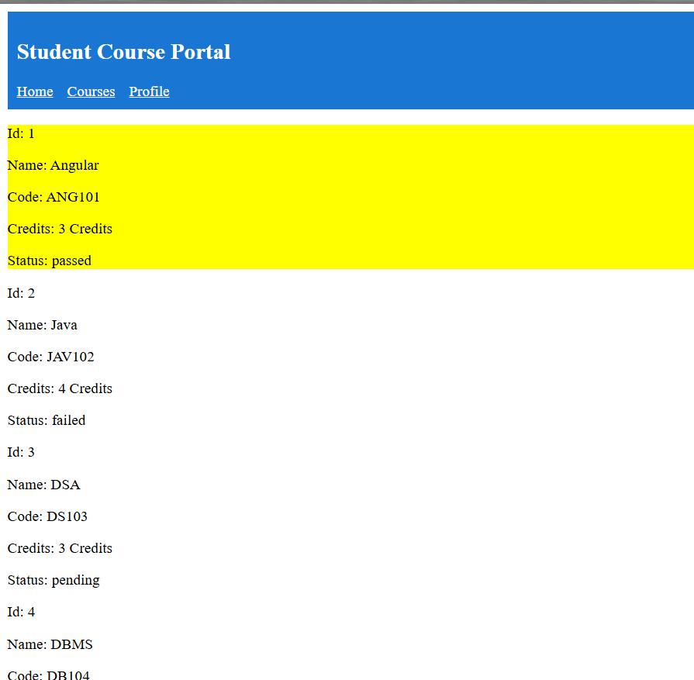
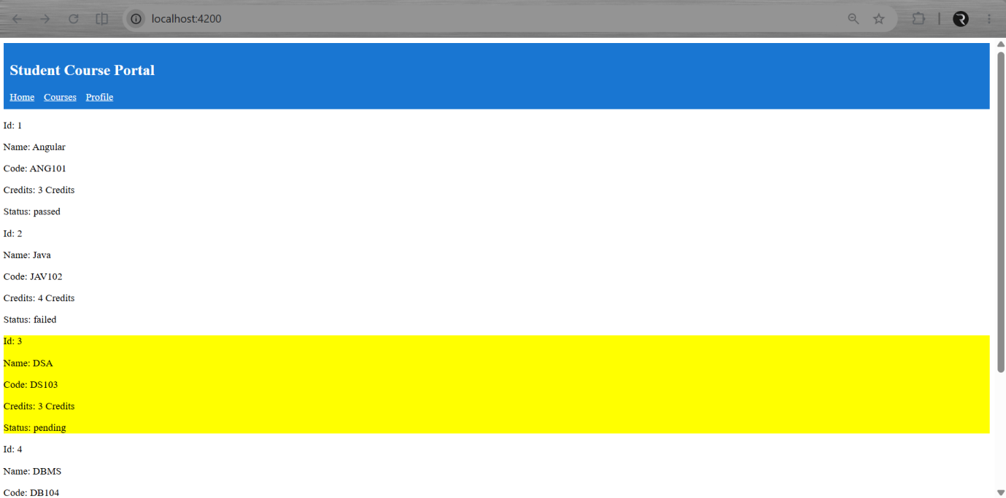

Exercise 4 : Template-Driven Forms & Validation
Task 1: Build the Enrollment Request Form
Scenario:
The application allows students to submit an enrollment request using a template-driven form.
It collects student details, course preferences, and validates input before submission.
Steps:
1. Generate EnrollmentFormComponent and add route /enroll.
2. Build a template-driven form using ngForm and ngModel.
3. Add required fields: name, email, courseId, semester, terms checkbox.
4. Implement onSubmit() to log form data and validity.
5. Disable submit button when form is invalid.
Solution Code:
app.routes.ts
import { EnrollmentFormComponent } from './pages/enrollment-form/enrollment-form.component';

export const routes = [
{ path: 'enroll', component: EnrollmentFormComponent }
];
enrollment-form.component.ts
import { Component } from '@angular/core';
import { FormsModule, NgForm } from '@angular/forms';
@Component({
selector: 'app-enrollment-form',
standalone: true,
imports: [FormsModule],
templateUrl: './enrollment-form.component.html'
})
export class EnrollmentFormComponent {
onSubmit(form: NgForm) {
console.log("Form Value:", form.value);
console.log("Form Valid:", form.valid);
}
}
enrollment-form.component.html
<h2>Enrollment Form</h2>
<form #enrollForm="ngForm" (ngSubmit)="onSubmit(enrollForm)">
<input
type="text"
name="studentName"
[(ngModel)]="studentName"
placeholder="Student Name"
required
/>
<br /><br />
<input
type="email"
name="studentEmail"
[(ngModel)]="studentEmail"
placeholder="Student Email"
required
/>
<br /><br />
<input
type="number"
name="courseId"
[(ngModel)]="courseId"
placeholder="Course ID"
required
/>
<br /><br />
<select
name="preferredSemester"
[(ngModel)]="preferredSemester"
required
>
<option value="">Select Semester</option>
<option value="Odd">Odd</option>
<option value="Even">Even</option>
</select>
<br /><br />
<label>
<input
type="checkbox"
name="agreeToTerms"
[(ngModel)]="agreeToTerms"
required
/>
I agree to terms
</label>

<br /><br />
<button type="submit" [disabled]="enrollForm.invalid">
Submit
</button>
</form>
Output:
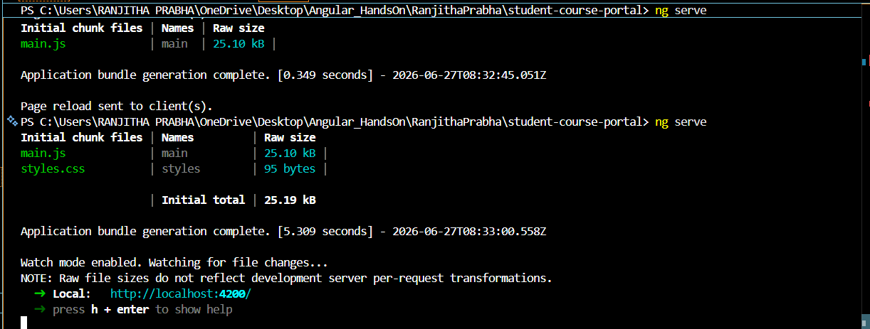
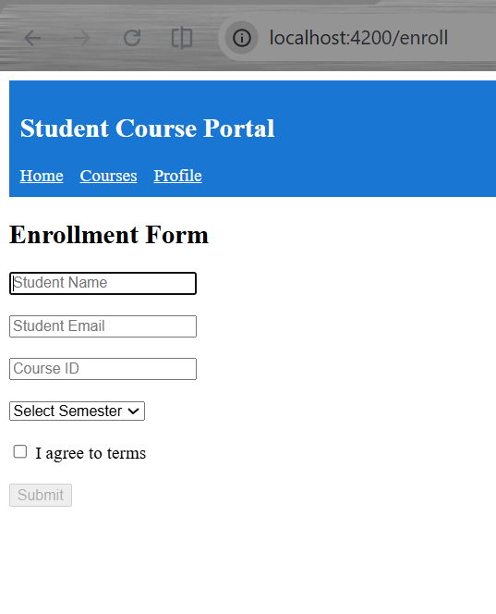
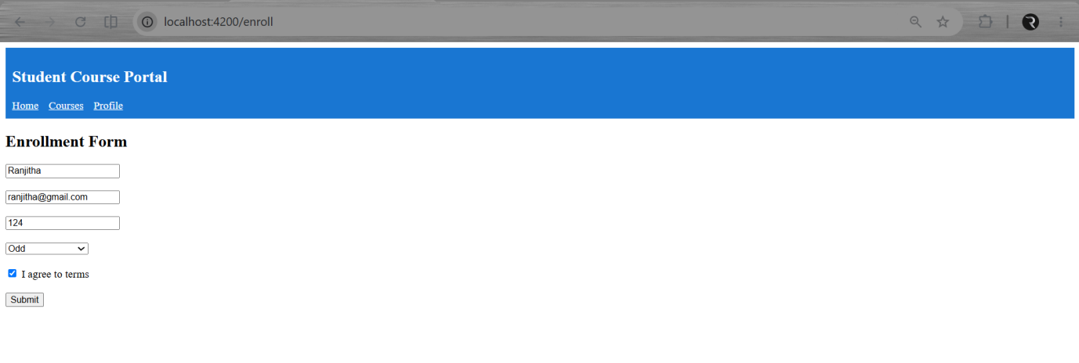

Task 2: Validation and Error Messages

Scenario:
The enrollment form validates user input before submission and displays appropriate error messages. It also provides visual feedback for valid and invalid fields.

Steps:
· Add built-in validators such as required, minlength, and email.
· Display validation error messages using ngModel and *ngIf.
· Apply CSS styles for valid and invalid input fields.
· Display a success message after successful form submission.
· Add a Reset button to clear the form and validation states.
Solution Code:
enrollment-form.component.ts
import { Component } from '@angular/core';
import { FormsModule, NgForm } from '@angular/forms';
import { CommonModule } from '@angular/common';

@Component({
selector: 'app-enrollment-form',
standalone: true,
imports: [CommonModule, FormsModule],
templateUrl: './enrollment-form.component.html',
styleUrls: ['./enrollment-form.component.css']
})
export class EnrollmentFormComponent {

studentName = '';
studentEmail = '';
courseId: number | null = null;
preferredSemester = '';
agreeToTerms = false;

submitted = false;

onSubmit(form: NgForm) {
console.log(form.value);
console.log(form.valid);

if (form.valid) {
this.submitted = true;
}
}
}
enrollment-form.component.html
<h2>Enrollment Form</h2>

<form #enrollForm="ngForm" (ngSubmit)="onSubmit(enrollForm)">

<!-- Student Name -->
<label>Student Name</label><br>

<input
type="text"
name="studentName"
[(ngModel)]="studentName"
#nameCtrl="ngModel"
required
minlength="3">

<br>

<span *ngIf="nameCtrl.touched && nameCtrl.errors?.['required']"
style="color:red;">
Name is required
</span>

<span *ngIf="nameCtrl.touched && nameCtrl.errors?.['minlength']"
style="color:red;">
Name must be at least 3 characters
</span>

<br><br>

<!-- Email -->

<label>Email</label><br>

<input
type="email"
name="studentEmail"
[(ngModel)]="studentEmail"
#emailCtrl="ngModel"
required
email>

<br>

<span *ngIf="emailCtrl.touched && emailCtrl.errors?.['required']"
style="color:red;">
Email is required
</span>

<span *ngIf="emailCtrl.touched && emailCtrl.errors?.['email']"
style="color:red;">
Enter a valid email
</span>

<br><br>

<!-- Course ID -->

<label>Course ID</label><br>

<input
type="number"
name="courseId"
[(ngModel)]="courseId"
#courseCtrl="ngModel"
required>

<br>

<span *ngIf="courseCtrl.touched && courseCtrl.errors?.['required']"
style="color:red;">
Course ID is required
</span>

<br><br>

<!-- Semester -->

<label>Preferred Semester</label><br>

<select
name="preferredSemester"
[(ngModel)]="preferredSemester"
required>

<option value="">Select</option>
<option value="Odd">Odd</option>
<option value="Even">Even</option>

</select>

<br><br>

<!-- Terms -->

<label>

<input
type="checkbox"
name="agreeToTerms"
[(ngModel)]="agreeToTerms"
#termsCtrl="ngModel"
required>

I Agree to Terms

</label>

<br>

<span *ngIf="termsCtrl.touched && termsCtrl.errors?.['required']"
style="color:red;">
Please accept the terms
</span>

<br><br>

<button type="submit"
[disabled]="enrollForm.invalid">
Submit
</button>

<button type="button"
(click)="enrollForm.resetForm()">
Reset
</button>
</form>
<br>
<div *ngIf="submitted" style="color:green;">
Enrollment request submitted successfully!
</div>
enrollment-form.component.css
.ng-invalid.ng-touched{
border:2px solid red;
}
.ng-valid.ng-touched{
border:2px solid green;
}
button{
margin-right:10px;
}
Output:
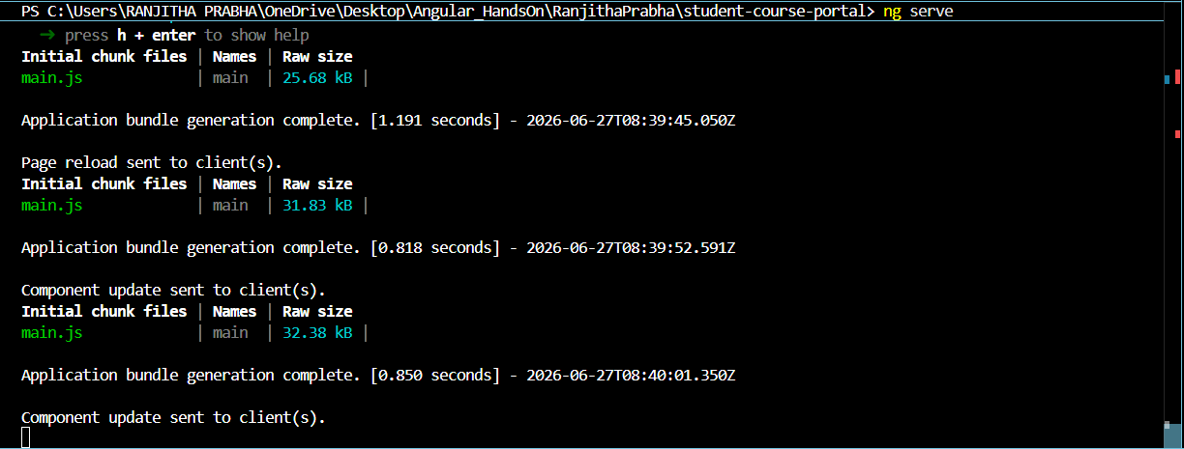

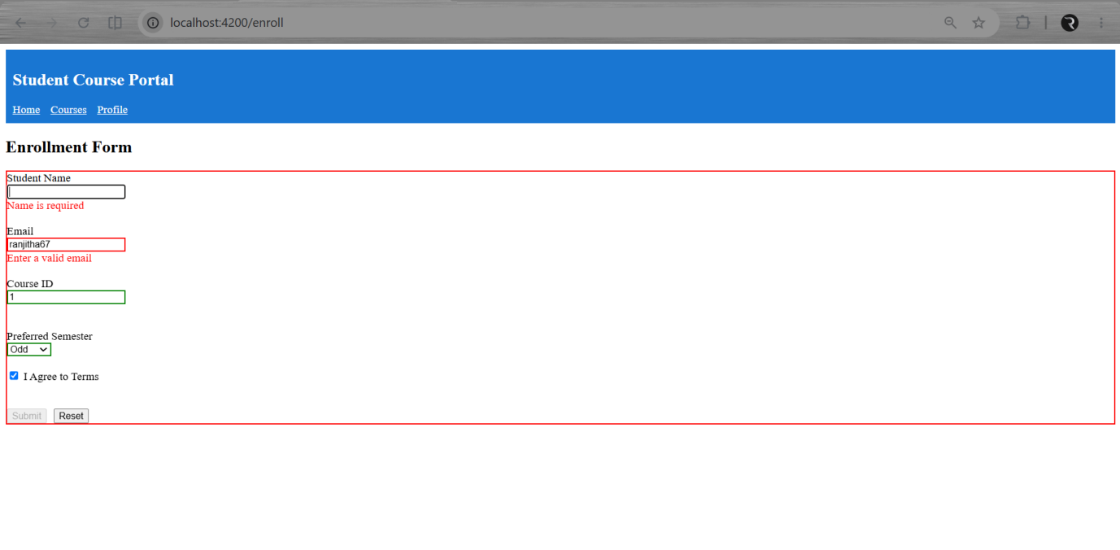
Exercise 5 : Reactive Forms — FormBuilder, FormGroup, FormArray & Custom Validators

Task 1: Build a Reactive Form with FormBuilder

Scenario:
The application provides a reactive enrollment form for students using Angular's Reactive Forms module. The form validates user input before allowing submission.

Steps:
1. Generate the ReactiveEnrollmentFormComponent and add a route /enroll-reactive.
2. Create the reactive form using FormBuilder and validators.
3. Bind the form controls using formGroup and formControlName.
4. Disable the Submit button until the form becomes valid.
5. Log the form values on successful submission.

Solution Code:
app.routes.ts
import { Routes } from '@angular/router';
import { CourseListComponent } from './pages/course-list/course-list.component';
import { EnrollmentFormComponent } from './pages/enrollment-form/enrollment-form.component';
import { ReactiveEnrollmentFormComponent } from './pages/reactive-enrollment-form/reactive-enrollment-form.component';

export const routes: Routes = [
{ path: '', component: CourseListComponent },
{ path: 'enroll', component: EnrollmentFormComponent },
{ path: 'enroll-reactive', component: ReactiveEnrollmentFormComponent }
];
reactive-enrollment-form.component.ts
import { Component, OnInit } from '@angular/core';
import { CommonModule } from '@angular/common';
import {
FormBuilder,
FormGroup,
Validators,
ReactiveFormsModule
} from '@angular/forms';

@Component({
selector: 'app-reactive-enrollment-form',
standalone: true,
imports: [CommonModule, ReactiveFormsModule],
templateUrl: './reactive-enrollment-form.component.html',
styleUrls: ['./reactive-enrollment-form.component.css']
})
export class ReactiveEnrollmentFormComponent implements OnInit {

enrollForm!: FormGroup;

constructor(private fb: FormBuilder) {}

ngOnInit(): void {

this.enrollForm = this.fb.group({

studentName: ['', [
Validators.required,
Validators.minLength(3)
]],

studentEmail: ['', [
Validators.required,
Validators.email
]],

courseId: [null, Validators.required],

preferredSemester: ['Odd', Validators.required],
agreeToTerms: [false, Validators.requiredTrue]

});

}
onSubmit() {
console.log("Form Value:", this.enrollForm.value);
console.log("Raw Value:", this.enrollForm.getRawValue());
}
}
reactive-enrollment-form.component.html
<h2>Reactive Enrollment Form</h2>

<form [formGroup]="enrollForm" (ngSubmit)="onSubmit()">

<label>Student Name</label><br>

<input
type="text"
formControlName="studentName">

<br><br>

<label>Email</label><br>

<input
type="email"
formControlName="studentEmail">

<br><br>

<label>Course ID</label><br>

<input
type="number"
formControlName="courseId">

<br><br>

<label>Preferred Semester</label><br>

<select formControlName="preferredSemester">

<option value="Odd">Odd</option>

<option value="Even">Even</option>

</select>
<br><br>
<label>
<input
type="checkbox"
formControlName="agreeToTerms">

I Agree to Terms
</label>
<br><br>
<button
type="submit"
[disabled]="enrollForm.invalid">
Submit
</button>
</form>
reactive-enrollment-form.component.css
input,
select{
width:250px;
padding:6px;
margin-bottom:10px;
}

button{
padding:8px 15px;
}
Output:
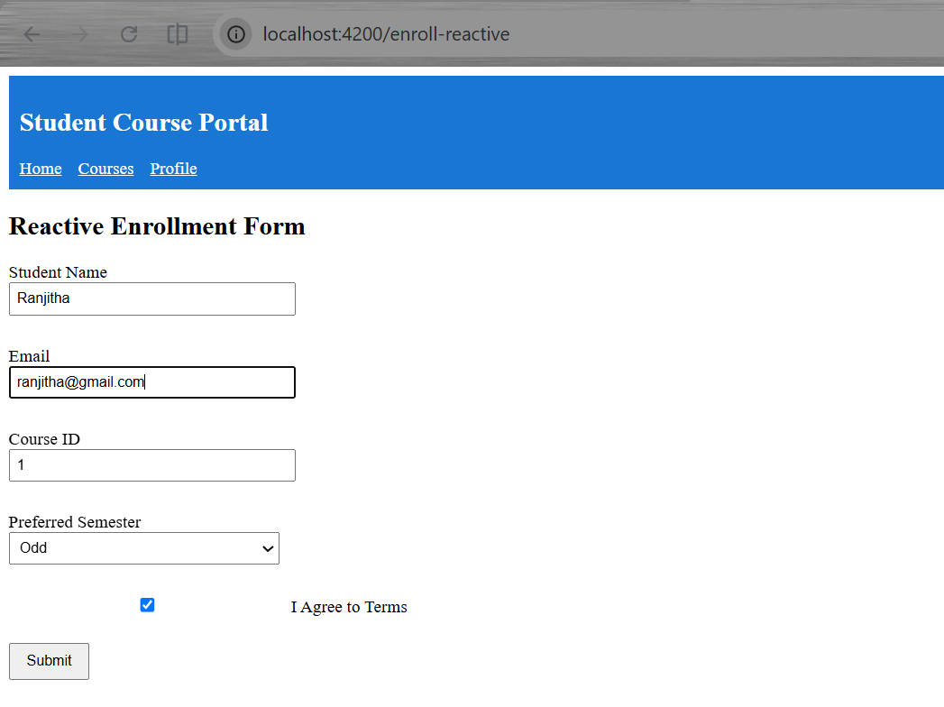
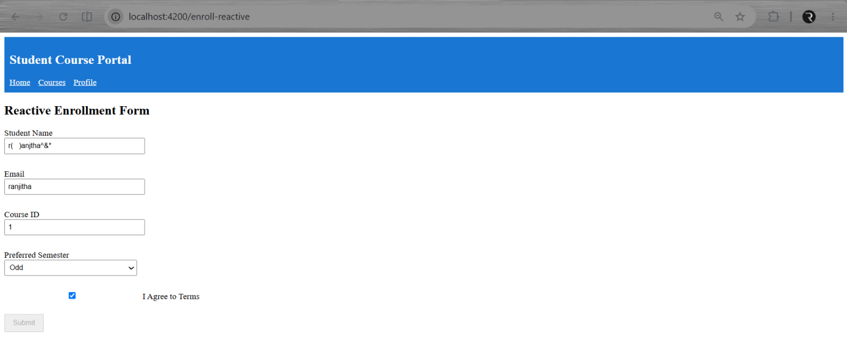

Task 2: Custom Validators and FormArray for Dynamic Controls

Scenario:
The reactive enrollment form validates custom business rules and allows students to dynamically add multiple course entries. It uses custom validators, asynchronous validation, and a FormArray.
Steps:
- Create a custom validator to reject course IDs starting with "XX".
- Add an asynchronous validator to check whether an email is already taken.
- Create a FormArray for dynamically adding additional course fields.
- Allow users to add and remove course inputs.
- Display validation messages for custom and asynchronous validators.

Solution Code:
reactive-enrollment-form.component.ts
import { Component, OnInit } from '@angular/core';
import {
FormBuilder,
FormGroup,
Validators,
ReactiveFormsModule,
AbstractControl,
ValidationErrors,
FormArray,
FormControl
} from '@angular/forms';
import { CommonModule } from '@angular/common';

@Component({
selector: 'app-reactive-enrollment-form',
standalone: true,
imports: [CommonModule, ReactiveFormsModule],
templateUrl: './reactive-enrollment-form.component.html',
styleUrls: ['./reactive-enrollment-form.component.css']
})
export class ReactiveEnrollmentFormComponent implements OnInit {

enrollForm!: FormGroup;
constructor(private fb: FormBuilder) {}
ngOnInit(): void {
this.enrollForm = this.fb.group({
studentName: [
'',
[Validators.required, Validators.minLength(3)]
],

studentEmail: this.fb.control(
'',
[Validators.required, Validators.email],
[this.simulateEmailCheck]
),

courseId: [
'',
[Validators.required, this.noCourseCode]
],

preferredSemester: [
'Odd',
Validators.required
],

agreeToTerms: [
false,
Validators.requiredTrue
],
additionalCourses: this.fb.array([])
});
}
// Custom Validator
noCourseCode(control: AbstractControl): ValidationErrors | null {
const value = control.value;
if (value && value.toString().startsWith('XX')) {
return { noCourseCode: true };
}
return null;
}
// Async Validator
simulateEmailCheck(control: AbstractControl): Promise<ValidationErrors | null> {

return new Promise(resolve => {

setTimeout(() => {

if (control.value && control.value.includes('test@')) {

resolve({ emailTaken: true });

} else {

resolve(null);

}

}, 800);

});

}

// Getter for FormArray
get additionalCourses(): FormArray {

// Getter keeps the template clean and avoids repeated casting.
return this.enrollForm.get('additionalCourses') as FormArray;

}

addCourse() {

this.additionalCourses.push(

new FormControl('', Validators.required)

);

}

removeCourse(index: number) {

this.additionalCourses.removeAt(index);

}

onSubmit() {

console.log(this.enrollForm.value);
}
}

reactive-enrollment-form.component.html
<h2>Reactive Enrollment Form</h2>

<form [formGroup]="enrollForm" (ngSubmit)="onSubmit()">

<label>Student Name</label><br>
<input type="text" formControlName="studentName">

<br><br>

<label>Email</label><br>
<input type="email" formControlName="studentEmail">

<br>

<span
style="color:red"
*ngIf="enrollForm.get('studentEmail')?.errors?.['emailTaken']">

Email already taken

</span>

<br><br>

<label>Course ID</label><br>

<input type="text" formControlName="courseId">

<br>

<span
style="color:red"
*ngIf="enrollForm.get('courseId')?.errors?.['noCourseCode']">

Course code starting with XX is not allowed.

</span>

<br><br>

<label>Semester</label><br>

<select formControlName="preferredSemester">

<option value="Odd">Odd</option>

<option value="Even">Even</option>

</select>

<br><br>
<label>
<input
type="checkbox"
formControlName="agreeToTerms">
Agree to Terms
</label>
<br><br>

<h3>Additional Courses</h3>

<button
type="button"
(click)="addCourse()">

Add Another Course

</button>

<br><br>

<div *ngFor="let ctrl of additionalCourses.controls; let i=index">

<input [formControl]="ctrl">

<button
type="button"
(click)="removeCourse(i)">
Remove
</button>
<br><br>
</div>
<button
type="submit"
[disabled]="enrollForm.invalid">
Submit
</button>
</form>

Output:

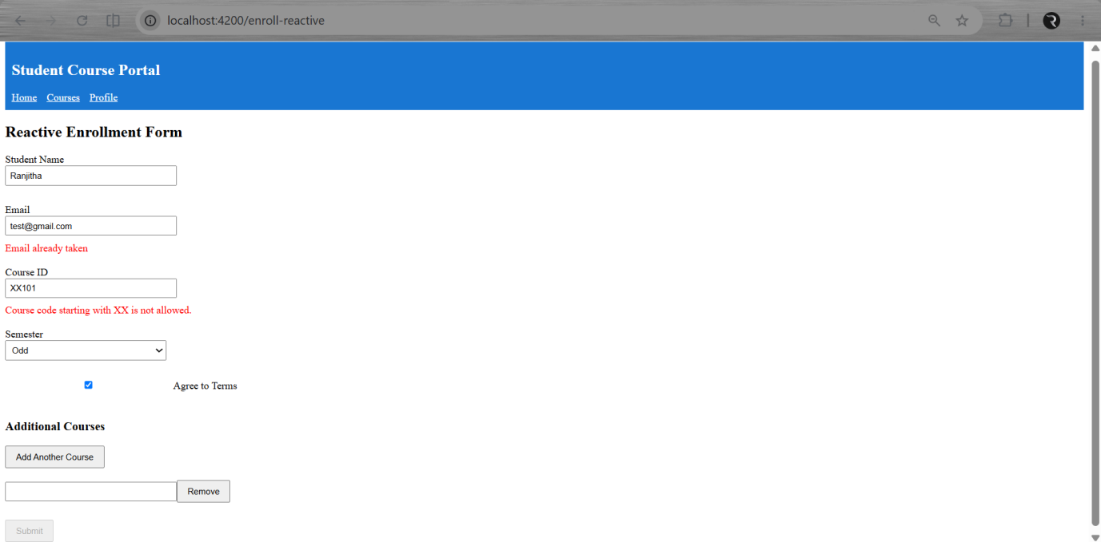

Exercise 6 : Services & Dependency Injection
Task 1: Create and Use a Course Service
Scenario:
The application uses a centralized Course Service to manage course data across multiple components. The service follows the singleton pattern, ensuring all components share the same data.

Steps:
1. Generate a CourseService and define course-related methods.
2. Create a Course interface to maintain type safety.
3. Inject the service into CourseListComponent to fetch course data.
4. Use the same service in another component to display the total number of courses.
5. Verify that both components share the same service instance.

Solution Code:
course.model.ts
export interface Course {

id: number;
name: string;
code: string;
credits: number;
gradeStatus: 'passed' | 'failed' | 'pending';
}

course.service.ts
import { Injectable } from '@angular/core';
import { Course } from '../models/course.model';

@Injectable({
providedIn: 'root'
})
export class CourseService {

private courses: Course[] = [

{
id:1,
name:'Angular',
code:'ANG101',
credits:3,
gradeStatus:'passed'
},

{
id:2,
name:'Java',
code:'JAVA102',
credits:4,
gradeStatus:'failed'
},

{
id:3,
name:'DBMS',
code:'DB103',
credits:3,
gradeStatus:'passed'
},

{
id:4,
name:'Cloud',
code:'CL104',
credits:4,
gradeStatus:'pending'
},

{
id:5,
name:'DSA',
code:'DS105',
credits:3,
gradeStatus:'passed'
}
];
getCourses(): Course[] {
return this.courses;
}
getCourseById(id:number): Course | undefined {
return this.courses.find(course=>course.id===id);
}
addCourse(course:Course): void{
this.courses.push(course);
}
}
course-list.component.ts
import { CourseService } from '../../services/course.service';
import { Course } from '../../models/course.model';
courses: Course[] = [];
constructor(private courseService: CourseService){}
ngOnInit(){
this.courses = this.courseService.getCourses();
}
home.component.ts
import { Component } from '@angular/core';
import { CourseService } from '../../services/course.service';

@Component({
selector:'app-home',
standalone:true,
templateUrl:'./home.component.html'
})
export class HomeComponent{

courseCount:number=0;
constructor(private courseService:CourseService){
this.courseCount=this.courseService.getCourses().length;
}
}
home.component.html
<h2>Home</h2>
<p>Total Courses : {{courseCount}}</p>
course-summary-widget.component.ts
import { Component } from '@angular/core';
import { CourseService } from '../../services/course.service';

@Component({
selector:'app-course-summary-widget',
standalone:true,
templateUrl:'./course-summary-widget.component.html'
})
export class CourseSummaryWidgetComponent{
count:number=0;
constructor(private courseService:CourseService){
this.count=this.courseService.getCourses().length;
}
}
course-summary-widget.component.html
<p>Total Courses Available : {{count}}</p>

Output:
Home:
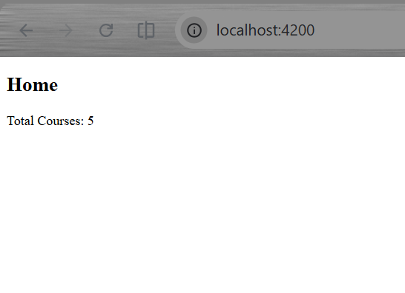
Courses:
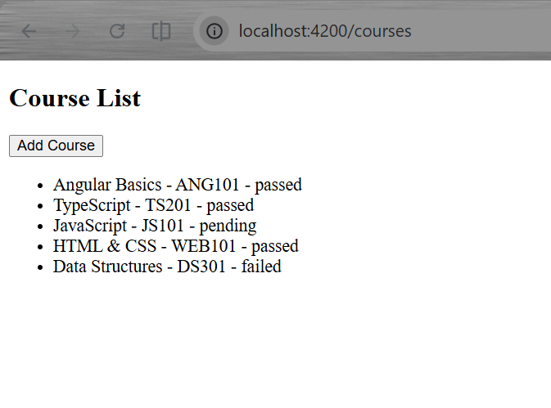
Task 2: Enrollment Service and Hierarchical DI
Scenario:
Create an EnrollmentService and demonstrate the DI hierarchy with component-level providers.
Steps:
- Create EnrollmentService with enrolled course ID list and methods for enroll/unenroll/check/list.
- Inject CourseService inside EnrollmentService to convert IDs → full course objects.
- Use EnrollmentService in CourseCardComponent to toggle Enroll/Unenroll button.
- Display enrolled courses in StudentProfileComponent using getEnrolledCourses().
- Create NotificationComponent with component-level provider to show DI hierarchy.
Solution Code:
enrollment.service.ts
import { Injectable } from '@angular/core';
import { CourseService } from './course.service';
import { Course } from '../models/course.model';

@Injectable({
providedIn: 'root'
})
export class EnrollmentService {

private enrolledCourseIds: number[] = [];

constructor(private courseService: CourseService) {}

enroll(courseId: number): void {
if (!this.enrolledCourseIds.includes(courseId)) {
this.enrolledCourseIds.push(courseId);
}
}

unenroll(courseId: number): void {
this.enrolledCourseIds = this.enrolledCourseIds.filter(id => id !== courseId);
}

isEnrolled(courseId: number): boolean {
return this.enrolledCourseIds.includes(courseId);
}

getEnrolledCourses(): Course[] {
return this.enrolledCourseIds
.map(id => this.courseService.getCourseById(id))
.filter((c): c is Course => c !== undefined);
}
}
Output:
